**K.santhana lakshmi**

**129**

**# Python program to show Linear Graph pyplot module**

import matplotlib.pyplot as plt

from matplotlib.figure import Figure

# initializing the data

x = [10, 20, 30, 40]

y = [20, 25, 35, 55]

fig = plt.figure(figsize = (5, 4))

# Adding the axes to the figure

ax = fig.add_axes([1, 1, 1, 1])

# plotting 1st dataset to the figure

ax1 = ax.plot(x, y)

# plotting 2nd dataset to the figure

ax2 = ax.plot(y, x)

# Setting Title

ax.set_title("Linear Graph")

# Setting Label

ax.set_xlabel("X-Axis")

ax.set_ylabel("Y-Axis")

# Adding Legend

ax.legend(labels = ('line 1', 'line 2'))

plt.show()

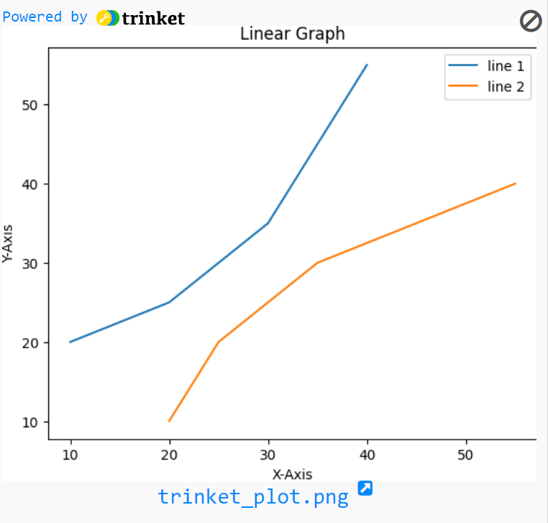

**#2 .bar chart**

import matplotlib.pyplot as plt

import pandas as pd

# Reading the tips.csv file

x = [10, 20, 30, 40]

y = [20, 25, 35, 55]

# plotting the data

plt.bar(x, y)

# Adding title to the plot

plt.title("bar chart")

# Adding label on the y-axis

plt.ylabel('y axis')

# Adding label on the x-axis

plt.xlabel('x axis')

plt.show()

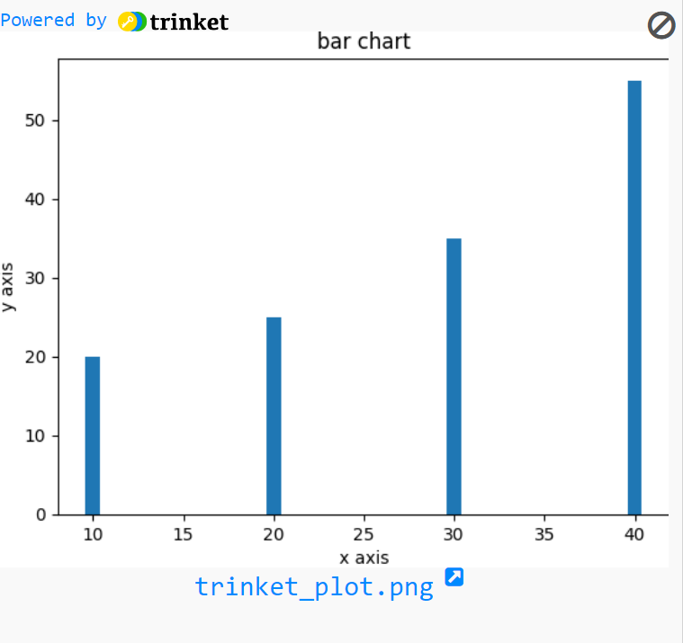

**#3. histogram**

import matplotlib.pyplot as plt

import pandas as pd

# plot x

x = [10, 20, 30, 40]

plt.hist(x, bins=10)

plt.show()

#. histogram

import matplotlib.pyplot as plt

import numpy as np

import pandas as pd

# Using numpy random function to generate random data

np.random.seed(19685689)

mu, sigma = 120, 30

x = mu + sigma * np.random.randn(10000)

# passing the histogram function

n, bins, patches = plt.hist(x, 70, histtype='bar', density=True, facecolor='yellow', alpha=0.80)

plt.xlabel('Values')

plt.ylabel('Probability Distribution')

plt.title('Histogram showing Data Distribution')

plt.xlim(50, 180)

plt.ylim(0, 0.04)

plt.grid(True)

plt.show()

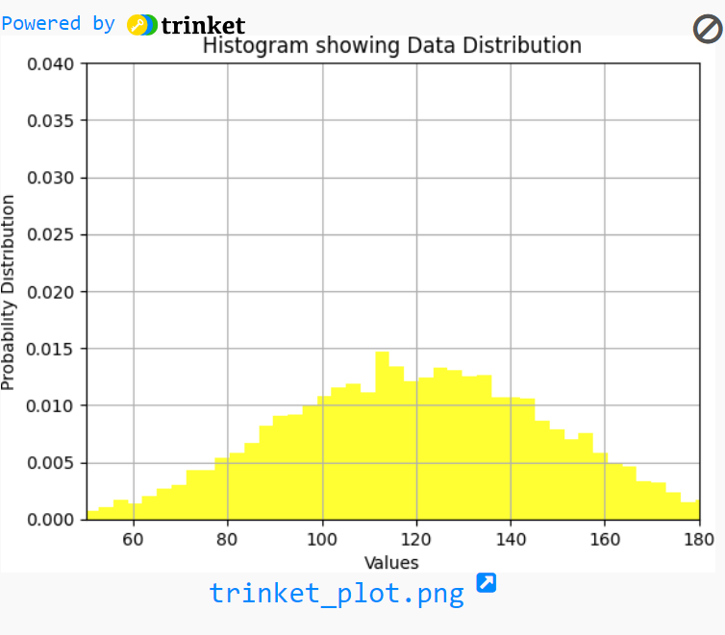

**#. 4. pie chart**

import matplotlib.pyplot as plt

import pandas as pd

# initializing the data

cars = ['AUDI', 'BMW', 'FORD',

'TESLA', 'JAGUAR',]

data = [23, 10, 35, 15, 12]

# plotting the data

plt.pie(data, labels=cars)

# Adding title to the plot

plt.title("Car data")

plt.show()

